DB Assignment 4

Leonidas Kesaris

11/4/2024

Constraints and Keys:

The above code displays the primary, foreign and composite keys which connect each table from one another. These keys followed the structure indicated on the image in the homework assignment page.

The above SQL script sets the constraints for the numerous tables within the SQL query. Each of the constraints in the assignment description is added to the tables withing the database via alter statements.

Problem 1.

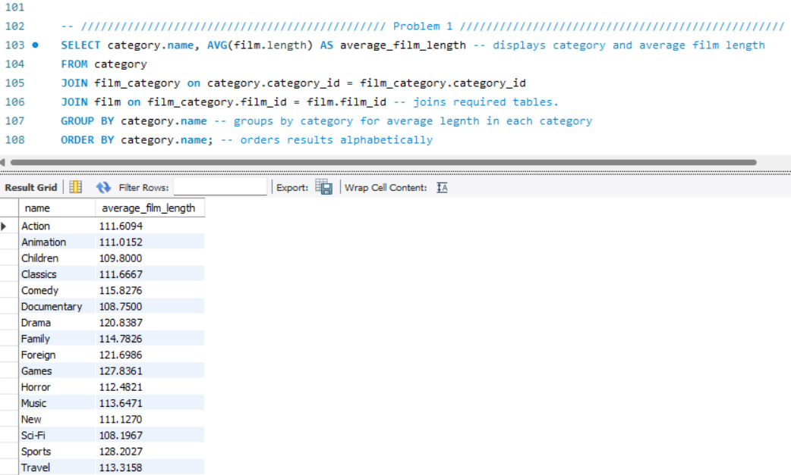

The above SQL Query calculates and lists the average film length in each category and orders these categories alphabetically. The group by category name calculates average length for each category, and then is ordered alphabetically.

Problem 2.

The above SQL Query uses the CTE AverageLengths to obtain the average length of films which are grouped by category. The longest film category is selected through the maximum average film length in the CTE and is labeled “Longest.” Next the shortest film is selected with the minimum average film length and is labeled “Shortest.” Finally, UNION ALL is used making a single output with both longest and shortest average lengths and category name displayed.

Problem 3.

The above SQL Query collects a list of distinct customers who have rented actions films, but not comedy or classic films. This is done by selecting distinct customer IDs and names and excluding the categories which are not desired through a NOT IN subquery which filters out categories Comedy and Classics.

Problem 4.

The above SQL Query indicates actors who have appeared in the most English language films. This is done by selecting actors, films and languages, and filtering by the language of English. Finally, the query groups the actors’ ID name and number of films for actor and orders the results in descending order to indicate the highest value first and limiting to 1 to show only the highest value.

Problem 5.

The SQL query above counts the number of unique movies which were rented for 10 days from the store which Mike works. The query counts distinct film ID’s from the rental table and joins inventory rental and film to access the needed data. Next staff is joined onto the store id of the inventory store ID to tie rentals to specific employees. The where statement filters the staff name to Mike and the date diff function is used to ensure that only rentals of 10 days are counted.

Problem 6.

The above SQL query displays actors who appeared in the movie with the largest cast. The query joins film_actor on actor and then utilizes a subquery in which the count function is used to find the film with the highest number of distinct actors and then grouping these results via film_actor and ordering by descending and limiting by 1 to display the maximum value. The individuals from the film with the highest number of cast members are then ordered alphabetically.